**How to Find your Student’s Infinite Campus ID**

To find a student's IC ID number in Infinite Campus for DCSD, parents can log in to the parent portal, navigate to the "Student Information" section, and locate the IC number. The IC is a unique identifier assigned to each student.

Elaboration:

1. **Log in to the Parent Portal:**

Parents will need to access the [DCSD Infinite Campus](https://campus.dcsdk12.org/icprod/portal/parents/icprod.jsp) Parent Portal.

1. **Navigate to Student Information:**

Once logged in, parents navigate to “Student Profile" section, often found by clicking on the student's name within the "Home" section.

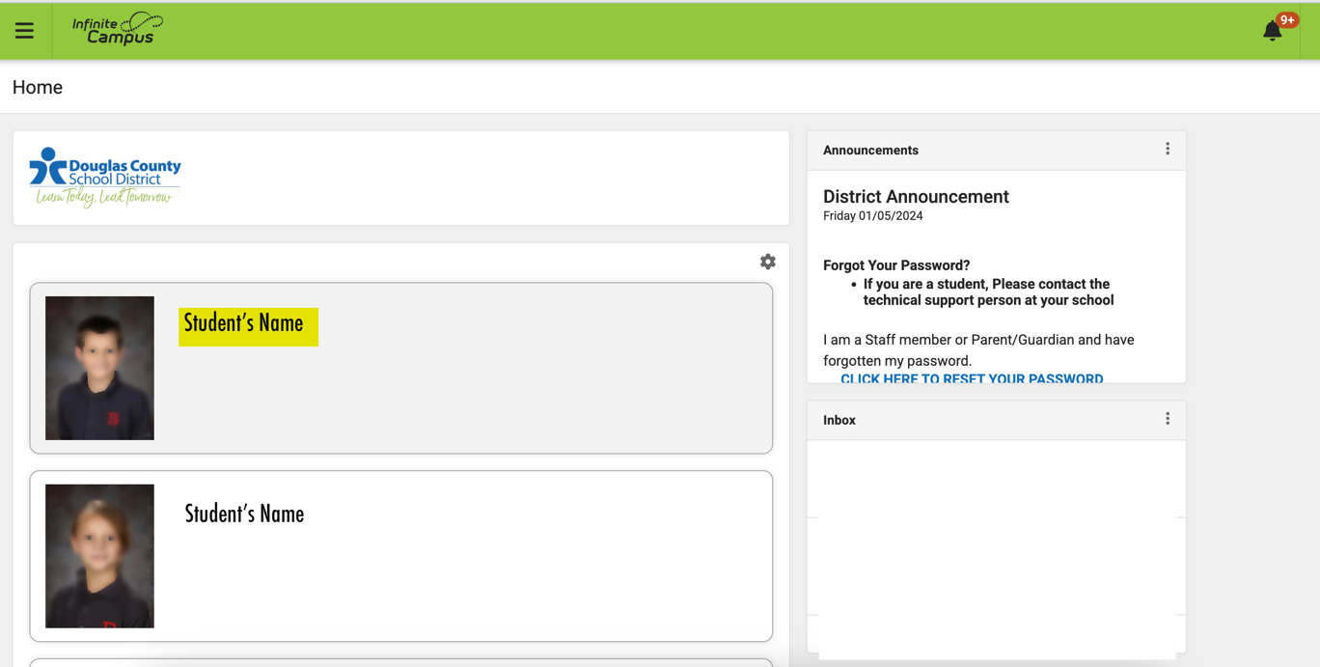

1. **Locate the SASID:**

Within the "Student Information," the Student number, also referred to as the IC and lunch room student identification number, will be displayed. This is NOT THE Student STATE ID.

**Forgot your username?**   
Look it up here - <https://www.dcsdk12.org/parents-students/resources/parent-it-support/password-reset>.

**Forgot your password?**   
Reset it here - <https://www.dcsdk12.org/parents-students/resources/parent-it-support/password-reset>